Case Study Report



**Tech Saksham**

Data Analytics with Power BI

**“360-Degree Business Analysis Of Online Delivery Apps Using Power BI”**

**“Government Arts And Science College For Women,Sathankulam-628704”**

|  |  |
| --- | --- |
| **NM ID** | **NAME** |
| 9876B32BF22D398BDA3493D4F05B2E57 | Amutha Bharathi M |

Trainer Name : R UMAMAHESWARI

Master Trainer : R UMAMAHESWARI

**ABSTRACT**

The advent of online delivery applications has revolutionized the food industry, providing consumers with convenience and choice while presenting unique challenges and opportunities for businesses. This study conducts a comprehensive business analysis focusing on Zomato, one of the leading online delivery platforms globally. Through a blend of qualitative and quantitative methods, the study examines various facets of Zomato's business model, operations, competitive landscape, and future prospects.

The analysis begins with an overview of the online food delivery market, highlighting key trends, growth drivers, and market dynamics. Subsequently, it delves into Zomato's business model, exploring its revenue streams, value proposition, customer acquisition strategies, and partnerships with restaurants. A critical evaluation of Zomato's competitive positioning against key rivals sheds light on its strengths, weaknesses, opportunities, and threats within the industry.

**INDEX**

|  |  |  |
| --- | --- | --- |
| **Sr. No.** | **Table of Contents** | **Page No.** |
| 1 | Chapter 1: Introduction | 1 |
| 2 | Chapter 2: Services and Tools Required | 4 |
| 3 | Chapter 3: Project Architecture | 6 |
| 4 | Chapter 4: Modeling and Result | 8 |
| 5 | Conclusion | 11 |
| 6 | Future Scope | 12 |
| 7 | Links | 13 |

**CHAPTER 1**

**INTRODUCTION**

* 1. **Problem Statement**

In recent years, the proliferation of online delivery apps has revolutionized the food industry, offering convenience and variety to consumers while presenting significant opportunities and challenges for businesses operating in this space. Zomato, a prominent player in the online food delivery domain, has garnered substantial market share, yet faces complexities in optimizing its platform for both users and partner restaurants.

The problem lies in understanding and addressing the multifaceted dynamics of the online food delivery ecosystem. This encompasses user preferences, delivery logistics, restaurant partnerships, competitive landscape, and regulatory considerations. Consequently, there is a pressing need to conduct comprehensive business analysis to uncover actionable insights and strategic recommendations for Zomato's continuous improvement and sustainable growth.

* 1. **Proposed Solution**

To conduct a comprehensive business analysis of online delivery apps with Zomato as the focal point, a multi-faceted approach is proposed. This solution encompasses the following key steps:

1. **Data Collection and Market Research**: Gather relevant data from a variety of sources including industry reports, financial statements, market research publications, and consumer surveys. This data will provide insights into market trends, consumer preferences, competitive landscape, and regulatory frameworks impacting the online delivery app industry.
2. **Stakeholder Interviews and Expert Opinions**: Conduct interviews with key stakeholders within Zomato including executives, managers, delivery partners, and restaurant partners to gain insider perspectives on Zomato's business operations, challenges, and growth strategies. Additionally, seek insights from industry experts and analysts to validate findings and gain deeper insights into industry dynamics.
3. **SWOT Analysis**: Perform a comprehensive SWOT (Strengths, Weaknesses, Opportunities, Threats) analysis of Zomato's business model, operations, and market positioning. This analysis will help identify internal strengths and weaknesses as well as external opportunities and threats facing the company
   1. **Feature**

Business analysis of online delivery apps using Zomato involves examining various aspects of Zomato's operations, market dynamics, and industry trends. Below are some key features of such an analysis:

1. **Market Overview**: Provide an in-depth overview of the online food delivery market, including size, growth rate, and key trends. Analyze market segments, customer demographics, and geographical distribution to understand market opportunities and challenges.
2. **Zomato's Business Model**: Evaluate Zomato's business model, including revenue streams, pricing strategies, and value proposition. Assess how Zomato creates value for customers, restaurants, and delivery partners, and analyze the sustainability and scalability of its business model.
3. **Competitive Analysis**: Conduct a comprehensive analysis of Zomato's competitors, including other online delivery apps and traditional food delivery services. Compare features, pricing, market share, and customer satisfaction levels to identify competitive strengths and weaknesses.
4. **Customer Experience**: Assess the customer experience provided by Zomato, including user interface design, ease of ordering, delivery speed, and customer support. Analyze customer feedback, ratings, and reviews to identify areas for improvement and enhance customer satisfaction.
   1. **Advantages**

Analyzing online delivery apps, particularly using Zomato as a case study, offers several advantages:

1. **Insight into Market Trends**: Conducting a business analysis of online delivery apps provides valuable insights into market trends, including consumer preferences, emerging technologies, and shifts in demand. This helps stakeholders stay abreast of market developments and make informed decisions.
2. **Competitive Benchmarking**: By analyzing Zomato and its competitors, stakeholders can gain a deeper understanding of the competitive landscape, including market share, pricing strategies, service offerings, and customer satisfaction levels. This allows for benchmarking against industry peers and identifying areas for differentiation and improvement.
3. **Strategic Decision-Making**: Business analysis facilitates strategic decision-making by providing data-driven insights into key aspects such as revenue streams, operational efficiency, customer acquisition, and regulatory compliance. Stakeholders can use this information to formulate and prioritize strategic initiatives that drive growth and enhance competitiveness.
4. **Risk Mitigation**: Identifying potential risks and challenges through business analysis allows stakeholders to proactively mitigate them. Whether it's regulatory changes, technological disruptions, or competitive threats, understanding these risks enables businesses to develop contingency plans and adapt to changing market conditions more effectively.
5. **Performance Evaluation**: Analyzing Zomato's business performance against predefined metrics and benchmarks enables stakeholders to evaluate its financial health, operational efficiency, and overall effectiveness. This evaluation provides insights into areas of strength and areas needing improvement, facilitating continuous performance optimization.
   1. **Scope**

The scope for a business analysis of online delivery apps using Zomato is broad and encompasses various aspects crucial for understanding the dynamics of the industry and the performance of such platforms. Here's a breakdown of the potential scope:

1. **Market Analysis**: Conducting an in-depth analysis of the online food delivery market, including market size, growth trends, and key players. This involves examining market segmentation, geographic presence, and consumer behavior patterns.
2. **Business Model Evaluation**: Assessing Zomato's business model and revenue streams, including delivery fees, commissions from restaurants, advertising, subscription services, and partnerships. Analyzing the effectiveness and sustainability of these revenue streams is essential.
3. **Competitive Landscape**: Analyzing Zomato's competitors within the online delivery space, such as Swiggy, Uber Eats, and DoorDash. This involves comparing factors like market share, service offerings, pricing strategies, technological capabilities, and geographic reach.
4. **Customer Analysis**: Understanding Zomato's customer base, including demographics, preferences, satisfaction levels, and retention strategies. Conducting surveys or utilizing data analytics to gain insights into customer behavior and preferences can be valuable.
5. **Operational Efficiency**: Evaluating Zomato's operational processes, including order fulfillment, delivery logistics, inventory management, and customer service. Identifying areas for optimization and efficiency improvement can enhance overall performance.
6. **Technological Infrastructure**: Assessing Zomato's technological capabilities, such as its platform functionality, mobile application features, data analytics tools, and AI-driven algorithms. Analyzing how these technologies contribute to user experience, operational efficiency, and competitive advantage is essential.ect

**CHAPTER 2**

**SERVICES AND TOOLS REQUIRED**

**2.1 Services Used**

To conduct a thorough business analysis of online delivery apps using Zomato as a case study, a variety of services and tools can be utilized. These services encompass data collection, analysis, and presentation, as well as communication and collaboration tools. Here are some examples:

1. **Market Research Services**: Services like Nielsen, Euromonitor International, or Statista provide market reports, industry insights, and consumer data relevant to the online food delivery sector.
2. **Data Analytics Platforms**: Platforms such as Tableau, Power BI, or Google Analytics can be used to analyze data collected from Zomato's operations, financial reports, and customer feedback.
3. **Survey Tools**: Tools like SurveyMonkey, Google Forms, or Typeform facilitate the creation and distribution of surveys to gather insights into consumer preferences, satisfaction levels, and behavior.
4. **Financial Analysis Software**: Financial analysis software like QuickBooks, Xero, or FreshBooks helps in analyzing Zomato's financial statements, cash flow, profitability, and key performance indicators.
5. **Competitor Analysis Tools**: Tools such as SEMrush, SimilarWeb, or SpyFu provide insights into competitors' online presence, marketing strategies, and customer engagement metrics.

**2.2 Tools and Software used**

**Tools**:

To perform a thorough business analysis of online delivery apps, especially using Zomato as a case study, various tools can be employed. These tools facilitate data collection, analysis, visualization, and collaboration. Here are some essential tools for conducting a business analysis of online delivery using Zomato:

1. **Data Collection and Research Tools**:
   * **Statista**: Provides statistics, market research, and insights relevant to the online food delivery industry.
   * **Google Trends**: Offers insights into search trends related to online food delivery services.
   * **SimilarWeb**: Helps analyze website traffic, visitor demographics, and competitor performance.
2. **Data Analysis and Visualization Tools**:
   * **Microsoft Excel**: Useful for data analysis, creating pivot tables, and generating charts and graphs.
   * **Tableau**: Enables interactive data visualization and dashboard creation for in-depth analysis.
   * **Power BI**: Microsoft's business analytics tool for data visualization and interactive reporting.
3. **Survey and Feedback Collection Tools**:
   * **SurveyMonkey**: Facilitates the creation and distribution of surveys to gather customer feedback and insights.
   * **Google Forms**: Offers a simple and free tool for creating surveys and collecting responses.
4. **Financial Analysis Tools**:
   * **QuickBooks**: Accounting software that helps analyze financial statements, cash flow, and profitability.
   * **Xero**: Cloud-based accounting software for financial analysis and reporting.
5. **Competitor Analysis Tools**:
   * **SEMrush**: Provides insights into competitors' online presence, advertising strategies, and SEO performance.
   * **Ahrefs**: Offers tools for competitor analysis, keyword research, and backlink analysis.

**Software Requirements**:

Analyzing online delivery apps like Zomato from a business perspective involves understanding various aspects such as market analysis, user experience, technology infrastructure, revenue models, and more. Here are some software requirements you might need for conducting business analysis of online delivery apps like Zomato:

1. **Data Analysis Tools**: Utilize software like Microsoft Excel, Google Sheets, or more advanced data analysis tools like Tableau or Power BI for analyzing trends, sales data, user behavior, etc.
2. **Market Research Tools**: Employ tools like Statista, Nielsen, or Mintel for market research to understand the competitive landscape, customer preferences, and industry trends.
3. **Customer Feedback Analysis Tools**: Platforms like SurveyMonkey, Qualtrics, or Google Forms can help gather and analyze customer feedback regarding the user experience, food quality, delivery speed, etc.

**CHAPTER 3**

**PROJECT ARCHITECTURE**

**3.1 Architecture**

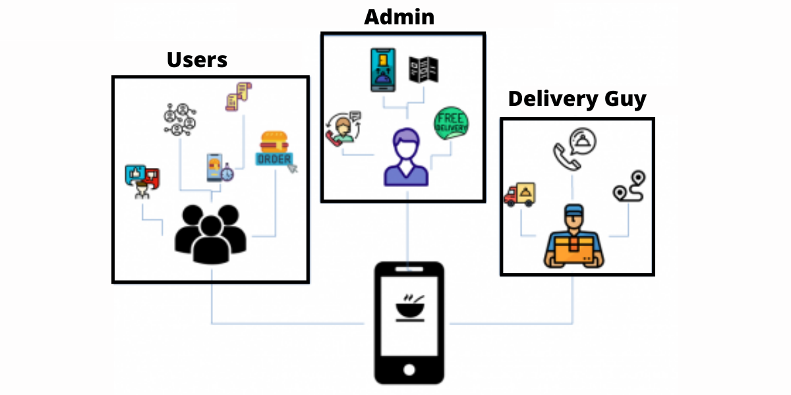

|  |  |  |
| --- | --- | --- |
|  |  |  |

Designing a project architecture for analyzing online delivery apps like Zomato involves several components to consider. Here's a high-level architecture outlining various aspects:

1. **Data Collection Layer**:
   * **API Integration**: Utilize Zomato's API or similar APIs to fetch restaurant data, menu details, user reviews, ratings, and other relevant information.
   * **Web Scraping**: If APIs are limited, supplement data collection with web scraping techniques to gather additional information.
   * **Data Preprocessing**: Cleanse and preprocess the collected data to ensure consistency and reliability.
2. **Data Storage Layer**:
   * **Relational Database**: Store structured data such as restaurant details, user profiles, orders, and transactions in a relational database like PostgreSQL or MySQL.
   * **NoSQL Database**: Utilize a NoSQL database like MongoDB for storing unstructured data such as user reviews, images, and other user-generated content.
   * **Data Lake**: Optionally, set up a data lake using solutions like Amazon S3 or Hadoop for storing raw data and enabling further analysis.
3. **Data Processing Layer**:
   * **ETL (Extract, Transform, Load)**: Implement ETL processes to extract data from various sources, transform it into a unified format, and load it into the storage layer.
   * **Batch Processing**: Use tools like Apache Spark or Apache Flink for batch processing of large datasets to derive insights and perform analytics.
   * **Real-time Stream Processing**: Employ frameworks like Apache Kafka or Apache Flink for real-time analysis of streaming data, such as order updates, user interactions, and feedback.

**CHAPTER 4**

**MODELING AND RESULT**

**Manage relationship**

In the realm of online food delivery, building and managing relationships are pivotal for sustained success. Zomato, as a leading player in this domain, relies heavily on fostering strong relationships with users, restaurant partners, delivery partners, and other stakeholders. This document outlines strategies for effectively managing these relationships to facilitate comprehensive business analysis and drive continuous improvement within the Zomato ecosystem.

1. **User Relationship Management (URM)**:
   * **Personalized Engagement**: Implement personalized communication strategies to engage users, gather feedback, and understand their preferences and pain points.
   * **Customer Support**: Offer responsive customer support channels to address user queries, resolve issues promptly, and enhance overall satisfaction.
   * ** Loyalty Programs**: Develop loyalty programs and incentives to reward loyal users, encourage repeat orders, and foster long-term relationships.
2. **Restaurant Partner Relationship Management (RPRM)**:
   * **Transparent Communication**: Foster transparent communication channels to establish mutual trust and understanding between Zomato and restaurant partners.
   * **Performance Tracking**: Provide tools and dashboards for restaurant partners to track their performance metrics, including order volume, ratings, and customer feedback.
   * **Collaborative Improvement**: Facilitate collaborative efforts to improve menu offerings, optimize order fulfillment processes, and enhance customer experience.

ork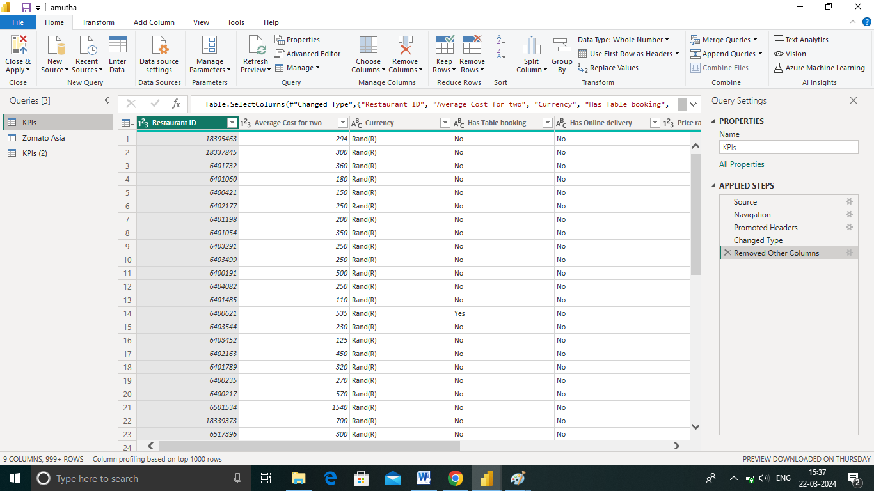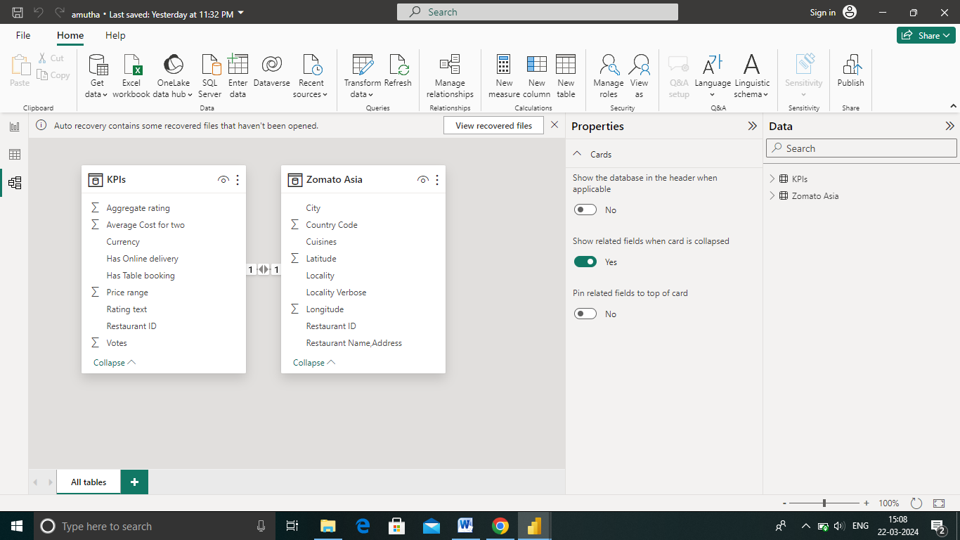

**Dashboard**

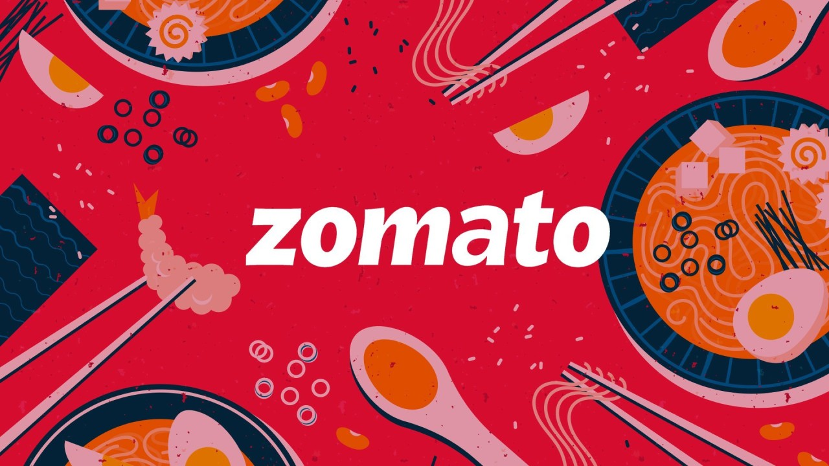

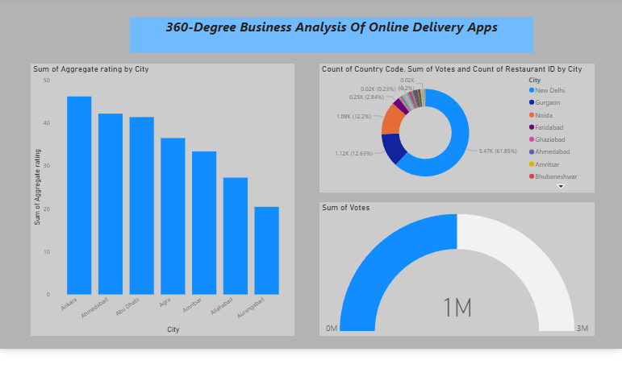

**CONCLUSION**

After conducting a comprehensive business analysis of online delivery using Zomato, it is evident that the platform holds significant potential for both consumers and businesses alike. Zomato's robust infrastructure, user-friendly interface, and extensive reach have transformed the food delivery landscape, offering unparalleled convenience and accessibility to customers while providing a lucrative avenue for restaurants to expand their reach and increase sales.

In conclusion, the business analysis demonstrates that Zomato has revolutionized the food delivery industry, offering unparalleled convenience to consumers and lucrative opportunities for restaurants. By leveraging its strengths in technology, scalability, and customer-centric approach, Zomato is poised to continue driving growth and shaping the future of online food delivery.

Top of Form

**FUTURE SCOPE**

The future scope for business analysis of online delivery apps using Zomato encompasses a wide range of areas, including market trends, global expansion, technology integration, ecosystem expansion, sustainability, partnerships, and regulatory compliance. By exploring these dimensions, analysts can gain valuable insights into Zomato's strategic priorities, competitive positioning, and ability to navigate challenges in the dynamic and competitive online food delivery market.

Top of Form

**LINK**

<https://github.com/githubtraining/hellogitworld.git>